 |  |  |  | Sprint 1
 |  | Stories |  |  | Story Points |  |  | Biz Value
Already Done: | ₊0 |  |  | 0 |  |  |  | 0
Sprint Plan:
 | +
Above Release Line | +
Total Release Plan:
 | =

Sprint Result:

Sprint 4

Stories Story Points Biz Value

Already Done:
+

Sprint Plan:
+

Above Release Line ₊

Total Release Plan:
=

Sprint Result:

Running Total:

Project Sprint Management Dashboard
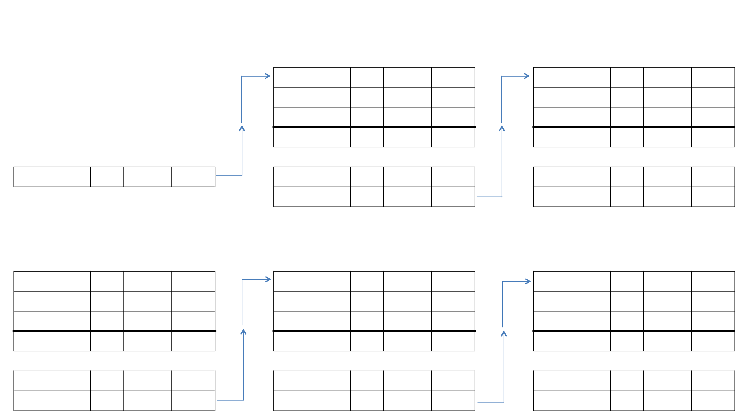

Sprint 2

Stories Story Points Biz Value

Already Done:
+

Sprint Plan:
+

Above Release Line ₊

Total Release Plan:
=

Sprint Result:

Running Total:

Sprint 5

Stories Story Points Biz Value

Already Done:
+

Sprint Plan:
+

Above Release Line ₊

Total Release Plan:
=

Sprint Result:

Running Total:

Sprint 3

Stories Story Points Biz Value

Already Done:
+

Sprint Plan:
+

Above Release Line ₊

Total Release Plan:
=

Sprint Result:

Running Total:

Sprint 6

Stories Story Points Biz Value

Already Done:
+

Sprint Plan:
+

Above Release Line ₊

Total Release Plan:
=

Sprint Result:

Running Total:

