WEEKLY SALES PLAN ACCT MGR | WEEK OF

I plan to make the following calls next week:

 | Business Name | My Agenda | Their Action | My Valid Busi ess Reason
 |  | How I’ll use my time with them... | The step(s) I want them to take... | Why they should want to meet with me

TARGET

PROSPECTS

& CLIENTS

KEY

CLIENTS

 | Business Name | My Agenda | Their Action | My Valid Busi ess Reason
 |  | How I’ll use my time with them... | The step(s) I want them to take... | Why they should want to meet with me

KEY

CLIENTS

SECONDARY

& EXTRAS

I plan to book the following orders next week:
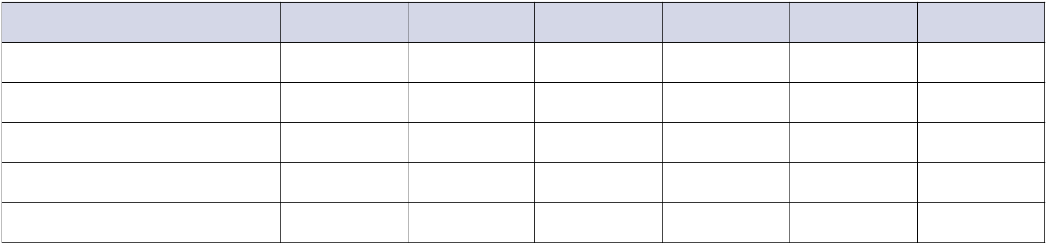

ACCOUNT | MONTH | $$$ | MONTH | $$$ | MONTH | $$$

