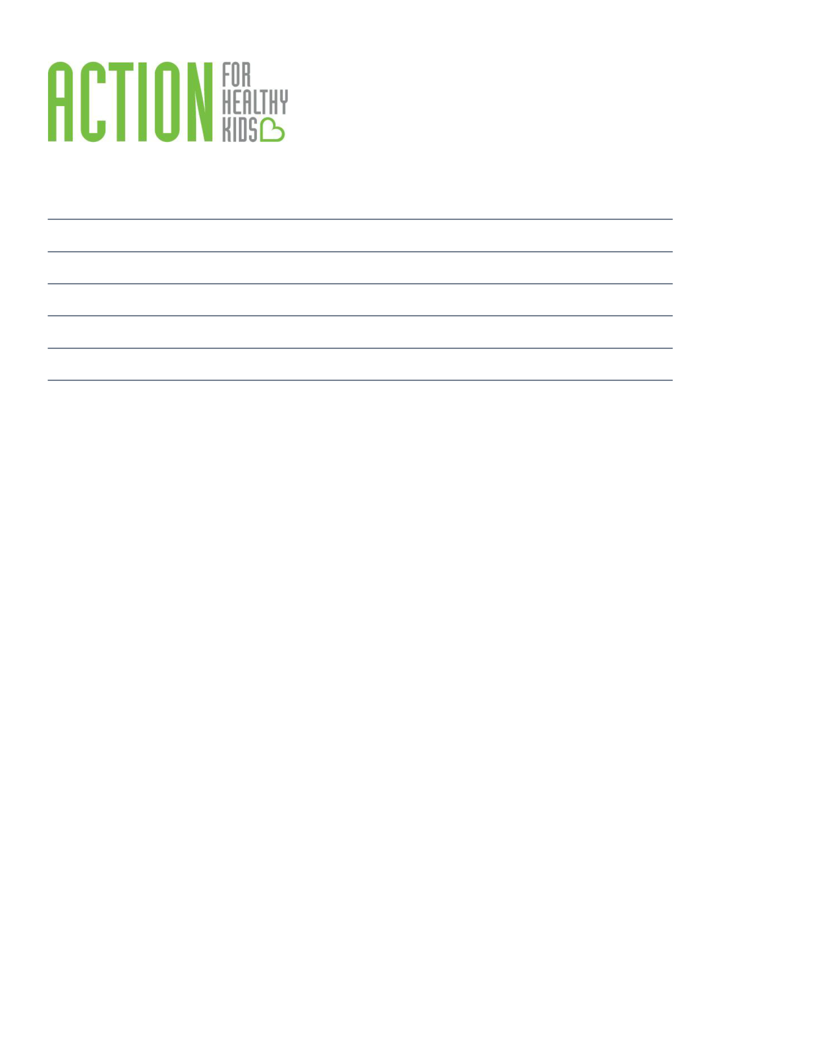
School Health

Team Meeting Agenda

Date:

Members Present:

Not In Attendance:

Facilitator:

Time Keeper:

Recorder:

Meeting Norms – Creating guidelines/rules with your Wellness Team Members to determine how the meeting should run For example, be positive and professional, be present, silence technology.

What | Process/Guiding Questions | Time
Opening and | Review the meeting norms and provide quick objectives for the meeting.
Announcements | Recommend keeping between 3-5 objectives for each meeting.
 | •
 | •
 | •
Business | List out each topic that must be discussed, who will be leading the topic,
 | and how long it will take to cover the topic.
 | • Review Action Items from last meeting
 | •
 | •
 | •
 | •
 | •



Process Check/ | Summarize your action items, set a date for your next meeting and evaluate
Wrap Up | how this meeting went or what needs to improve.

Meeting Evaluation

- What went well? o

o o

- What do we need to improve upon for next time? o

o o

Action Items | List out Action Items and put the person’s name responsible for the action
 | item next to each.



Notes:

