 |  |  |  |  |  |  |  |  | GYM NAME HERE

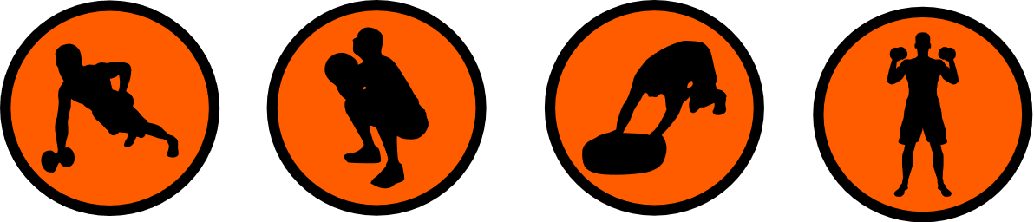
DAILY WORKOUT PLAN
 | ROUTINE
 |  | 01 JAN 2026 |  |  |  |  |  |  | GYM NAME HERE
 |  | 31 JAN 2026 |  |  |  |  |  |  | ADDRESS HERE
 | * Morning exercises can boost energy and metabolism for the day, try to start exercising by 9:00AM
 | 10 min |  |  | Pushups (3 sets, 15 reps, bodyweight)
 |  |  |  | Hands shoulder-width, lower chest to floor, push back up.
 | 5 min |  |  | Squats (3 sets, 12 reps, bodyweight)
 |  |  |  | Feet shoulder-width, bend knees, lower hips, stand back up.
 | 8 min |  |  | Bench Press (3 sets, 10 reps, 50 kg)
 |  |  |  | Lie on bench, lower bar to chest, press back up.
 | 4 min |  |  | Deadlift (3 sets, 8 reps, 70 kg)
 |  |  |  | Feet hip-width, lift bar from floor, stand straight.
 | 6 min |  |  | Pull-ups (3 sets, 10 reps, bodyweight)
 |  |  |  | Hang from bar, pull chin above bar, lower back down.
 | 10 min |  |  | REST TIME
 |  |  |  | Pause and relax for 10 minutes to recover and recharge your energy.
 | 8 min |  |  | Lunges (3 sets, 12 reps, bodyweight)
 |  |  |  | Step forward, lower hips, return to start, alternate legs.
 | 10 min |  |  | Bicep Curls (3 sets, 15 reps, 10 kg)
 |  |  |  | Stand, curl dumbbells to shoulders, lower back down.
 | 7 min |  |  | Tricep Dips (3 sets, 12 reps, bodyweight)
 |  |  |  | Hands on bench, lower body, push back up.
 | 5 min |  |  | Shoulder Press (3 sets, 10 reps, 20 kg)
 |  |  |  | Stand, press dumbbells overhead, lower back down.

