 | WORKOUT LOG CALENDAR |  |  |  |  |  |  |  |  |  | 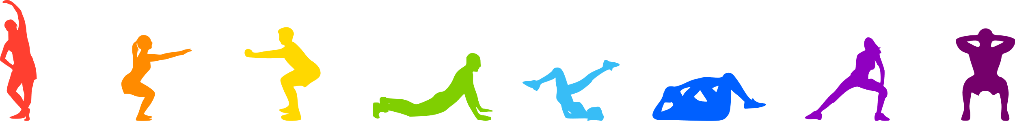 |  |  |  |  | MARCH 2026
 | SUNDAY |  |  | MONDAY |  |  | TUESDAY |  |  | WEDNESDAY |  |  | THURSDAY |  |  | FRIDAY |  |  | SATURDAY
 |  | 1 |  |  | 2 |  |  | 3 |  |  | 4 |  |  | 5 |  |  | 6 |  |  | 7
 | REST DAY |  |  | Push-ups  Squats  Plank  Jumping Jacks  Lunges |  |  | Sit-ups  Deadlifts  Mountain Climbers  High Knees  Tricep Dips |  |  | Pull-ups  Leg Raises  Russian Twists  Calf Raises  Bicycle Crunches |  |  | Leg Press  Flutter Kicks  Box Jumps  Shoulder Press  Dumbbell Rows |  |  | Hamstring Curls  V-Ups  Skaters  Chest Flyes  Renegade Rows |  |  | Jump Rope  Kettlebell Swings  Hollow Hold  Lateral Raises  Goblet Squats
 |  | 8 |  |  | 9 |  |  | 10 |  |  | 11 |  |  | 12 |  |  | 13 |  |  | 14
 | REST DAY |  |  | Push-ups  Squats  Plank  Jumping Jacks  Burpees |  |  | Dips  Hamstring Curls  Skaters  Chest Flyes  Renegade Rows |  |  | Jump Rope  Kettlebell Swings  Hollow Hold  Tuck Jumps  Lateral Raises |  |  | Pull-ups  Russian Twists  Side Plank  Calf Raises  Bicycle Crunches |  |  | Sit-ups  Deadlifts  Mountain Climbers  Bicep Curls  Tricep Dips |  |  | Bench Press  Leg Press  Box Jumps  Shoulder Press  Dumbbell Rows
 |  | 15 |  |  | 16 |  |  | 17 |  |  | 18 |  |  | 19 |  |  | 20 |  |  | 21
 |  | 22 |  |  | 23 |  |  | 24 |  |  | 25 |  |  | 26 |  |  | 27 |  |  | 28
 |  | 29 |  |  | 30 |  |  | 31

