

My Bullet Journal

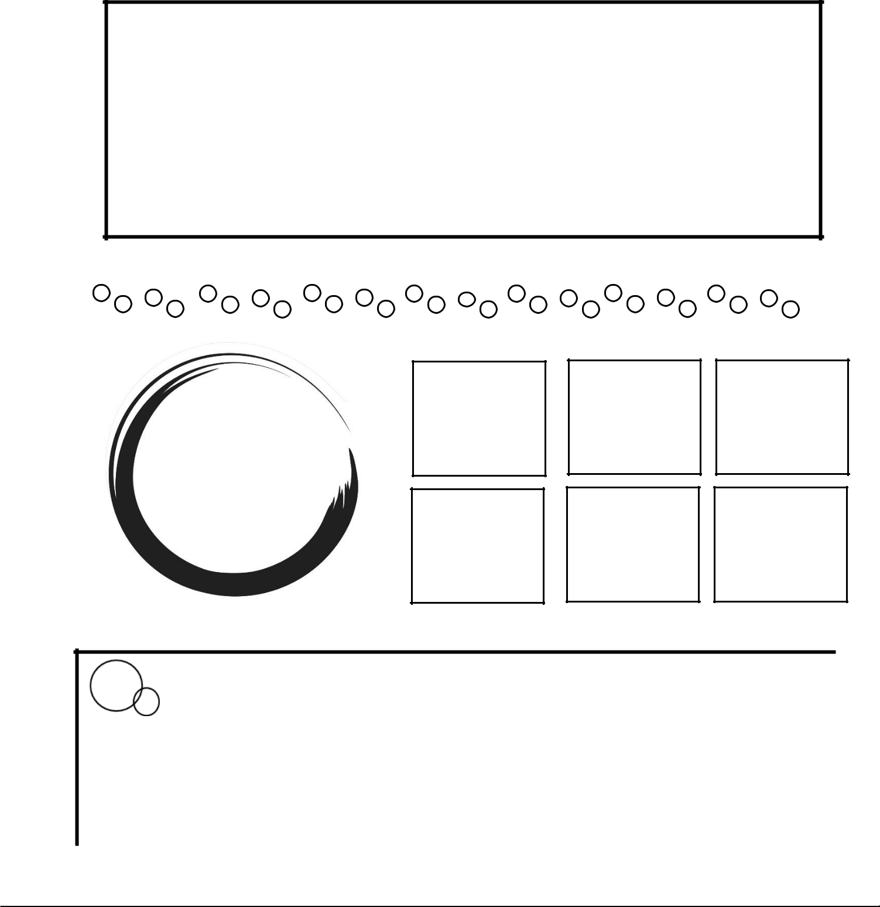
Detail:
Title:
Bullet 1:
Bullet 1:
Bullet 1:
Bullet 1:
Bullet 1:
Bullet 1:
This week at-a-glance

- Monday

- Saturday

- Tuesday

➢ Sunday

- Wednesday

- Thursday

- Notes

- Friday

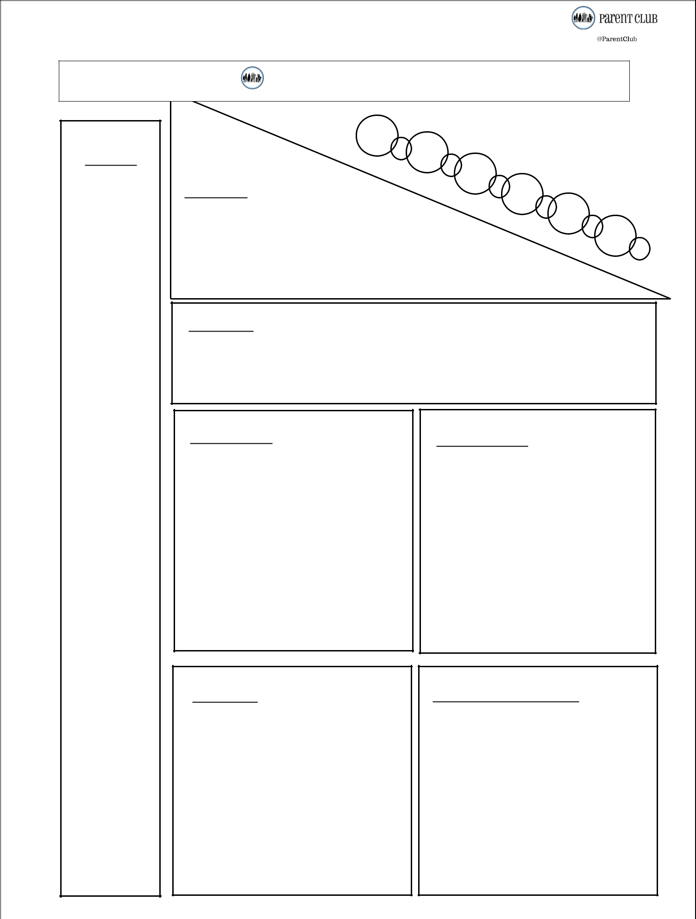
Chores & Organization
Notes
Repairs
Storage
Bedrooms | Bathrooms
Kitchen | Garage & outside



Shopping List
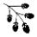
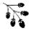



 Creative Journal



My goal this week is

Self-Care this week is

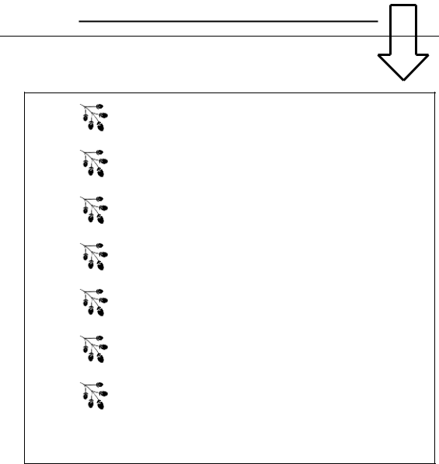

Creative Space



Activities



Meal Plan

 Monday

Tuesday

Wednesday

Thursday

Friday


Saturday

 Sunday

Gratitude Journal

