
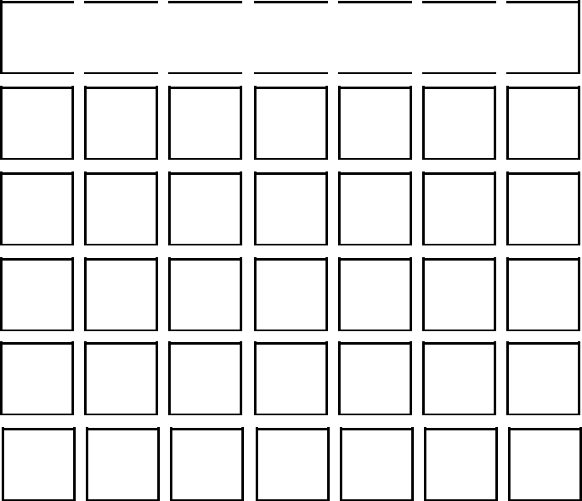
MON TUE WED THU FRI SAT SUN

 | GOALS |  |  |  | TO-DO
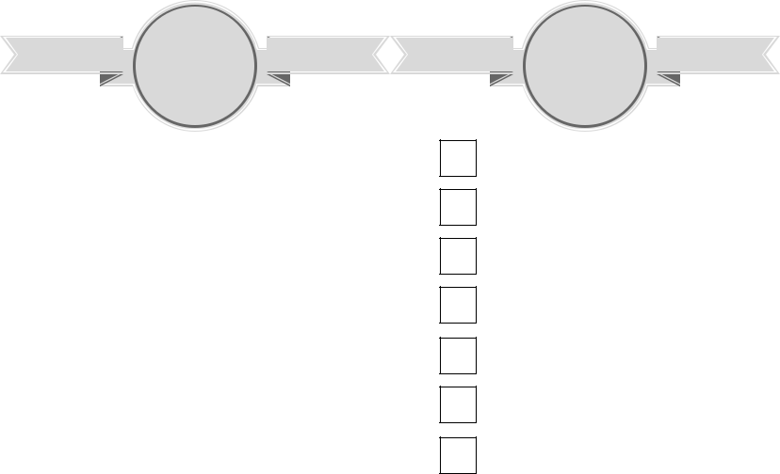
habit^{HABIT TRACKER}tracker


- 2 3 4 5 6 7 8 9 101112 131415161718 1920 21222324252627 28293031



NOTESnotes
MONDAY monday

TUESDAY tuesday

WEDNESDAY wednesday
THURSDAY thursday

FRIDAY friday

WEEKEND weekend

