Travel  Planner

Packing List

Expenses in Total

DATE:
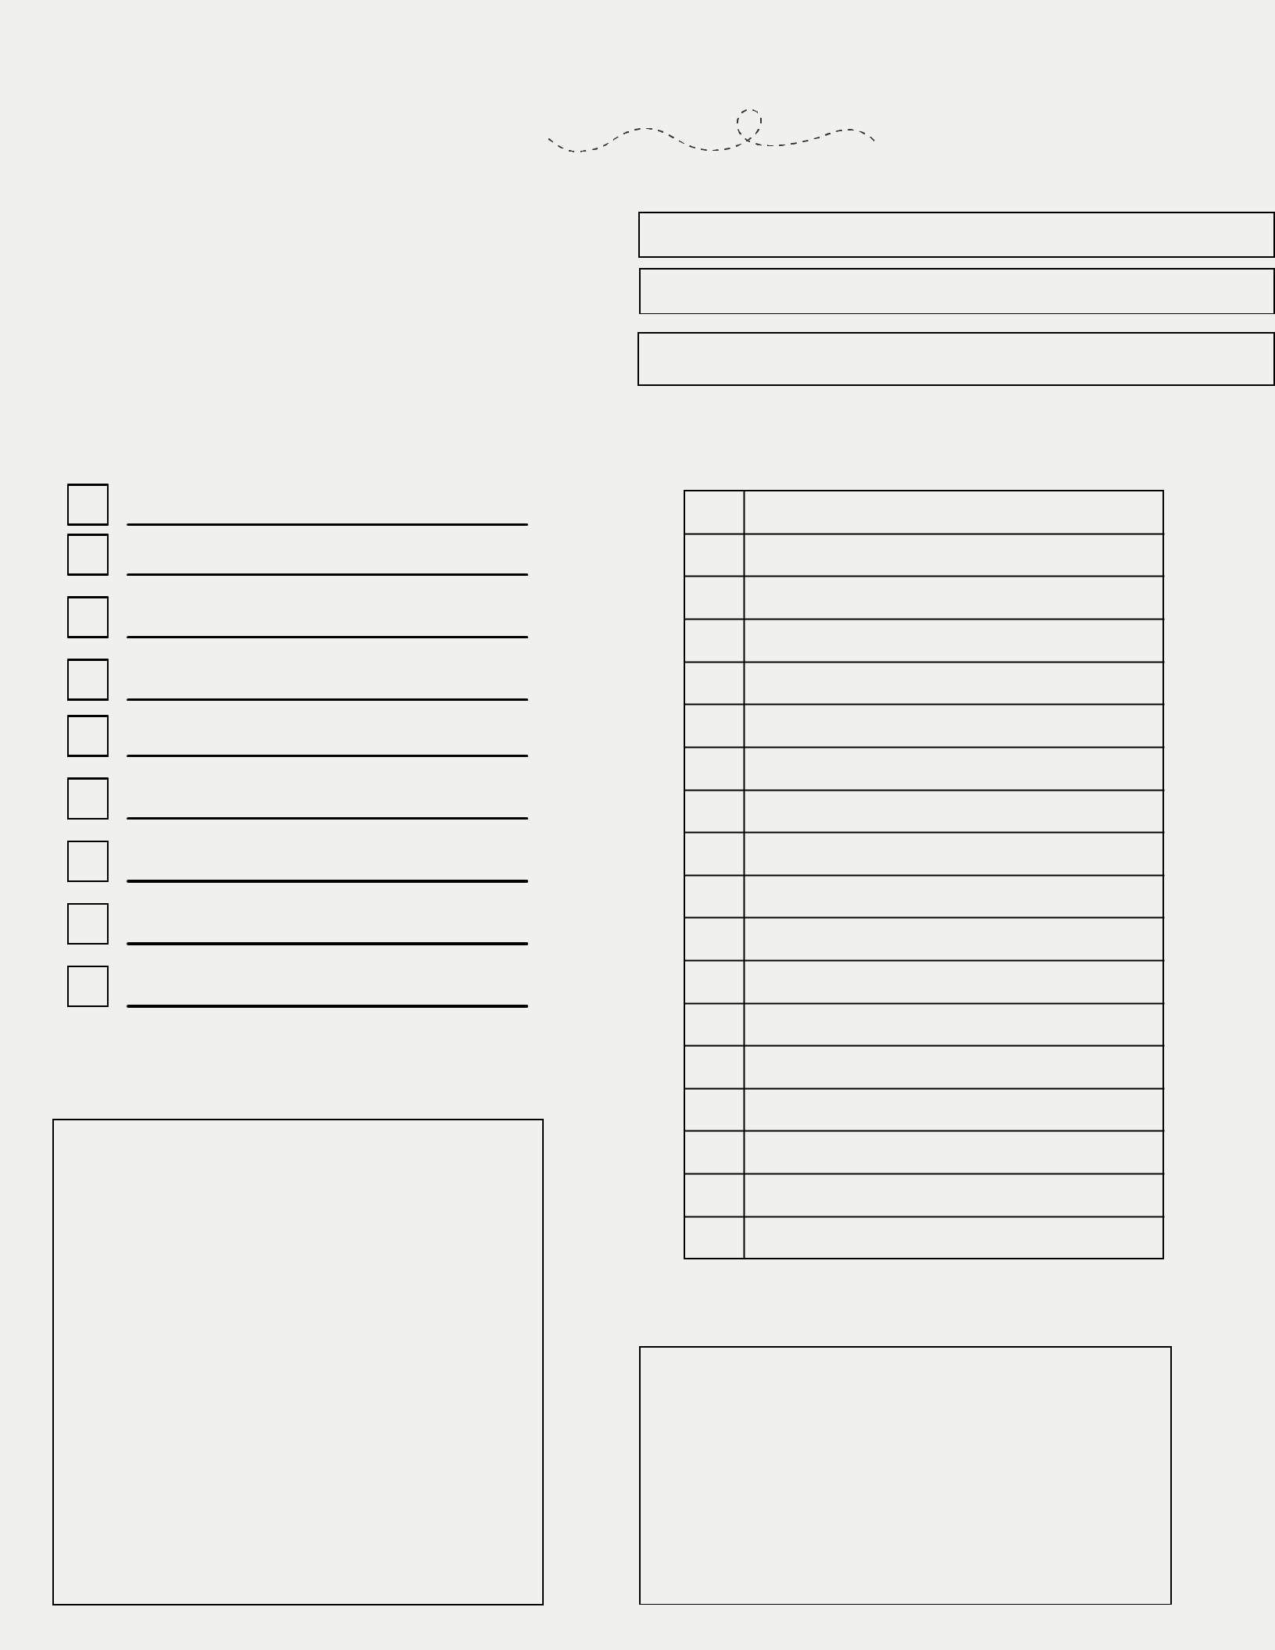

DURATION:

DESTINATION:

Schedule

Notes

