Trip Planning Template

Use the first section of this planning template to curate possible resources to include in your virtual field trip. In the second section, you will narrow these resources to plan the pre-activities, during activities, and post-activities of your virtual field trip.

Section 1: Curated Resources

Standards and Learning Objectives

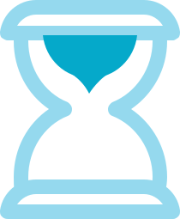
Standards:

•

Learning Objectives:

•

See

What can your students watch and/or interact with to experience this location? Consider using tools like Google Maps, Google Earth, live webcams, and premade virtual tours. Curate a list of all possible ideas and links here. You may not use all of these.

•

Hear

What can your students listen to experience this location? Are there sound effects, local music, experts to contact? Consider using tools like YouTube, Spotify, and reaching out to subject area experts. Curate a list of all possible ideas and links here. You may not use all of these.

•

Section 1: Curated Resources (continued)

Touch

What might be some manipulatives and artifacts that you can have available for your students to touch and play with during the field trip. Consider reaching out to local colleges/universities, museums, historical societies, and/or businesses for resources. Curate a list of all possible ideas here and include contact information if necessary. You may not use all of these.

•

Smell

What might be some things that your students would smell if they were really on this field trip? How might you bring those smells into the classroom? Curate a list of all possible ideas here and where you would find these items. You may not use all of these.

•

Taste

What might be some things your students would have the opportunity to taste if they were really on this field trip? Curate a list of all possible ideas and where you would find these. You may not use all of these.

•

Do

What activities might your students engage in? Consider the 4Cs: Communication, Critical Thinking, Collaboration, Creativity. Curate a list of all possible ideas and links here. You may not use all of these.

•

Section 2: Field Trip Planning

Before

What can you do to build excitement, curiosity, and anticipation for your virtual field trip?

•

What activities will your students need to complete before embarking on the virtual field trip?
•

What resources will you need to gather, create, distribute, etc.?

•

Who do you need to contact? (Subject matter experts, additional “chaperones”, virtual tour guides, etc.)
•

During

Create an agenda (with times) of what will occur during the virtual field trip. Be sure to include links, resources, etc. with each event/activity. Remember to consider the experiences students would have on a real field trip. What steps can you take to recreate some of that magic in your classroom?
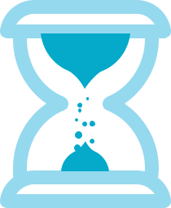
•

Section 2: Field Trip Planning (continued)

After

What activities will your student complete to show their learning from this experience? (4Cs)
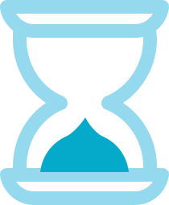
•

What activities might you offer to extend their learning?

•

Who might you need to send “Thank you” notes to?

•

What aspects of the virtual field trip will you change next time?

•

Template Content Created by Lauren Boucher http://laurenjboucher.com

