Term Sheet Template

PROJECT NAME:

DATE:

The outline template below is a guide only, and may be adapted as required to fit the nature of the project. The intention, however, should be to provide at least all the information asked for, but further information can be provided if this is felt to be useful to inform potential financiers. Entries under each heading should not exceed a few sentences – the whole term sheet would typically be no more than 3 pages
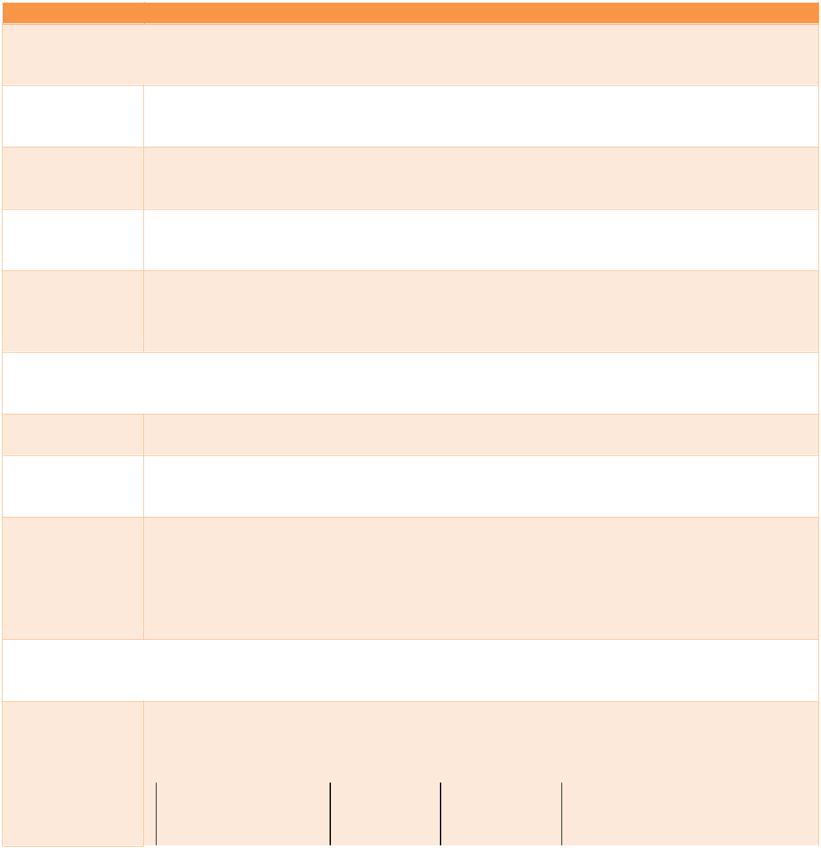

Term Details

BACKGROUND TO AND OBJECTIVES OF THE PROJECT

The

Transaction /
Project

Background to / Purpose of the Project

Climate
results

Environmental

and social
impact
assessments

Short description of the deal or project, e.g. number of wind farms, their location and capacity

Short introduction to / context for the project, and its purpose – e.g. climate policies which the project will help execute, NDC or SDG goal(s) which could be relevant to the project
Summary of mitigation (e.g. GHG reductions) or adaptation outcomes (e.g. number of direct and indirect beneficiaries, number of beneficiaries relative to total population)

Summary of assessments and management plans to be implemented

PARTIES TO THE PROJECT / TRANSACTION

Project Sponsor Special Purpose Entity(ies)

Other Parties to Transaction

The developer or other proponent of the project or fund and its ownership / jurisdiction

Describe any special purpose entity(ies) required to implement the project and its / their purpose / ownership / jurisdiction

List of the other parties to the transaction and role they will play, for example:

- [Commercial Bank]: Term Debt

- [DFI]: Partial risk guarantee
- [Specialist equity fund]: Equity in project developer
- [Government]: Permits for XYZ
- [Offtaker]: XX-year PPA

FINANCING DETAILS

Financing Table setting out what the proceeds of the transaction would be used for, e.g. Requirements planning, design, development of XX MW of solar PV at locations Z, Y. If there
there is a mix of technologies, specify the costs and role of each technology

 | Project |  | Amount |  | Likely
 | phases/activities |  | Required |  | Investment
 |  |  |  |  | Type (e.g.

Sources of Finance

Note: the

information
requested
below the table

(“Closing Date”

down to
“Conditions
Precedent”)
may be
included in the
table via extra
columns, or in

separate
table(s) on
particular
investment
elements

Closing Date / Sequencing
Currency(ies)

Terms

 |  |  | and |  | grant,
 |  |  | Currency |  | equity,
 |  |  |  |  | debt)
 | [Project Phase A] |  | [insert |  | [insert
 |  |  | amount] |  | amount]
 | [Project Phase B] |  | [insert |  | [insert
 |  |  | amount] |  | amount]
 | [Insert additional |  | [insert |  | [insert
 | project phases as |  | amount] |  | amount]
 | relevant]
 | TOTAL |  | [insert |  | [insert
 |  |  | amount] |  | amount]

Show the mix of different types of finance / risk mitigation instruments that will be needed to cover the financing requirements identified above. Some examples are mentioned below

Investment type, e.g. | Investment | Investor/Party
as below junior / | amount
mezzanine / senior | and
debt, equity, | currency
guarantees, currency
hedging instruments
TA or project | [insert | [specify the type of funder or
development grant | amount] | counterparty]
Equity: specify type, | [insert | [specify the type of funder or
e.g. ordinary, preferred, | amount] | counterparty]
convertible
Debt: specify junior / | [insert | [specify the type of funder or
mezzanine / senior and | amount] | counterparty]
security
Guarantees: specify | [insert | [specify the type of funder or
first loss / pro rata / | amount] | counterparty]
partial
Hedging instruments: | [insert | [specify the type of funder or
currency / interest rate | amount] | counterparty]
etc

Date on which the transaction is expected to close or expected sequencing of the raising of the different types of finance

List the currency(ies) that will be involved in the transaction. If the currency of the liabilities (debt etc) is different to the currency in which the revenues to service the liabilities are different, then how hedging of this risk will be achieved should be addressed

List the key terms for each type of financing, e.g. for debt:

- Benchmark

- Margin
- Term
- Repayment profile
- Seniority
- Collateral
- Covenants (especially any ‘green covenants’)

E.g. for equity:

- Type (ordinary, preferred, convertible etc)

- Expected returns and how delievered (e.g. preference coupons, IRR)
- Conversion terms


Sources of | List the source of (re)payment for each type of financing, e.g. business revenues,
(Re)Payment | refinancing, conversion. For sources of (re)payment of initial financing, the intended
 | counterparty (e.g. PPA counterparty) should be specified, along with credit rating of
 | counterparty, term of contract etc
Hedging | Currency or interest rate hedging arrangements to be put in place
Arrangements
Guarantees | Guarantee or export finance arrangements etc. Indicate level and type of
 | guarantee, e.g. first loss / pro rata, full / partial and rate of the latter. Indicate cost.
Covenants | Describe any key covenants required, especially covenants to secure ‘green’ /
 | social objectives of the project
Green | If debt is to be issued under a green label, state the use of proceeds and the type of
Loan/Bond | appraisal for the green label (e.g. second opinion)
Issuance
Conditions | Briefly describe and conditions that will need to be met before financing can close,
Precedent to | e.g.:
Closing | - Due diligence conditions
 | - Putting in place relevant Services Agreements
 | - Any policy changes required at national or local level
 | - Any planning agreements required
 | - Completion of the Transaction Documents
 | - Agreement of tax arrangements, hedging arrangements

TRANSACTION ARRANGEMENTS / COSTS

Transaction Documents

Advisers Fees and

Expenses

Governing Law & Arbitration

KEY RISKS

Dependent on the nature of the Transaction, briefly list the documentation envisaged to be needed for the Transaction e.g. Share Subscription Agreement, Loan Agreements, Guarantee Agreements, Hedging Contracts
List intermediaries and technical, legal, accountancy advisers etc required to arrange / complete the transaction / project (actual names not needed)

Expected fees and expenses to be incurred in completing the Transaction / paying the above advisers, e.g. arrangement fees, retainer and success fees, advisory costs, costs of consents / permissions etc

Jurisdiction(s) / national law(s) under which the agreements would be entered into, plus main arbitration arrangements (i.e. with respect to finance only, hence depends on the source of the finance)

List the key risks associated with the project and what mitigation measures are in place / contemplated to address these. Some examples of risks might be:

- Political

- Technology
- Currency
- Commercial
- Key Person
- Security
- Refinancing

