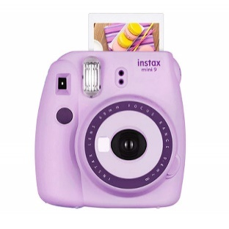  Valued at: $000 | AUCTION BID SHEET
 |  |  | INSTANT CAMERA
 |  |  | BID AMOUNT | NAME | CONTACT
 | Donated by:
 | Mr.XYZ
 | Item Description:
 | Minimum Bid Increase:
 | 0000$
 |  |  | THANK YOU

