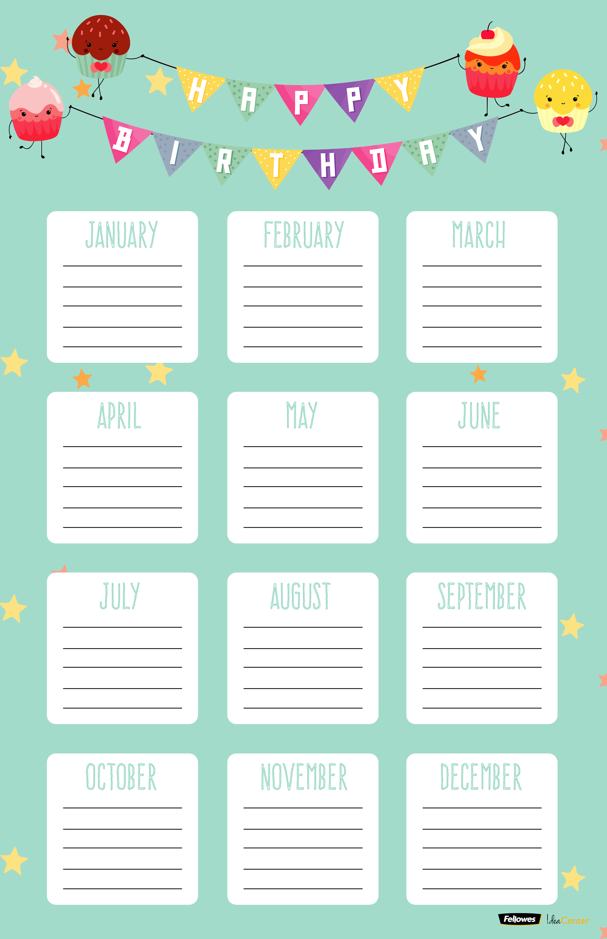

JANUARY FEBRUARY MARCH

APRIL MAY JUNE

JULY AUGUST SEPTEMBER

OCTOBER NOVEMBER DECEMBER

