PROJECT SUMMARY REPORT TEMPLATE
Project Summary Form

This form is available for use by diplomates needing to submit evidence of MOC Part 4 satisfaction through PQI project completion.

Diplomates who completed a PQI activity must complete the PQI Activity form.
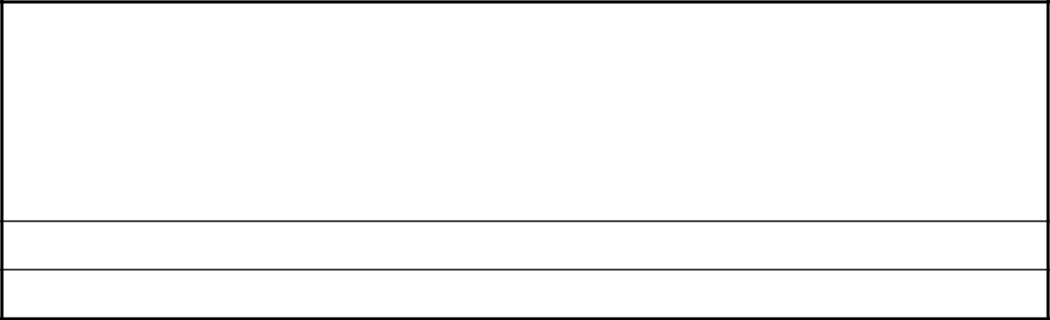

 |  | Section 1: Diplomate Details
 | Enter diplomate contact and practice information below.
 | Name: |  | ABR ID:
 | Email: |  | Phone:
 | Position Title:

Institution/Practice Name:

Institution/Practice City/State:

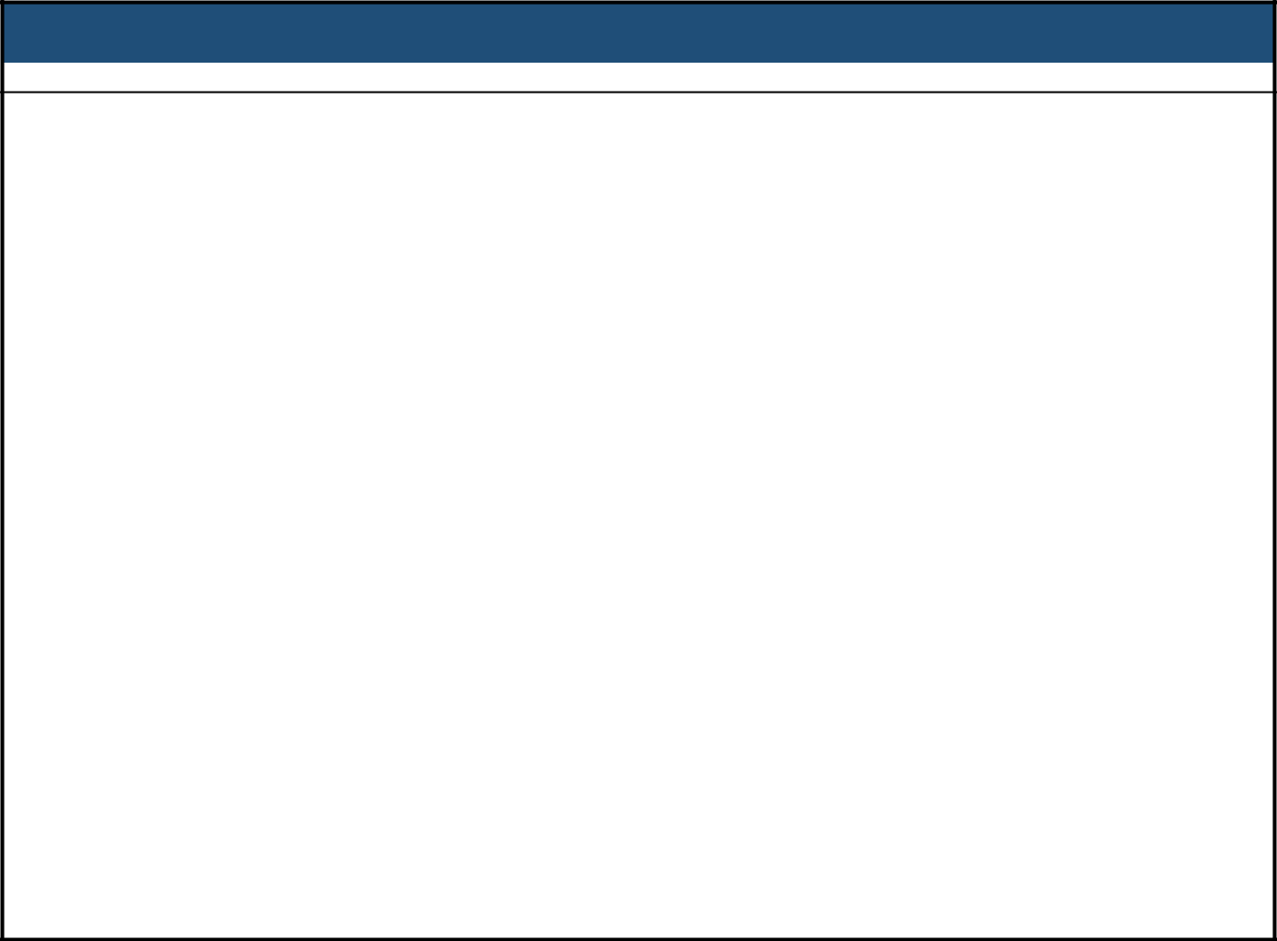
Section 2: Participatory Quality Improvement Project Details

Provide details of the PQI project the diplomate completed within the last three calendar years.

Project Title:
Project Start Date: | Project Completion Date:
Significance Statement:
Initial Expectation and Planned Evaluation:
Describe the method used to complete the project:


Provide a final project summary:

Briefly describe the project’s impact on patient safety and/or quality improvement:
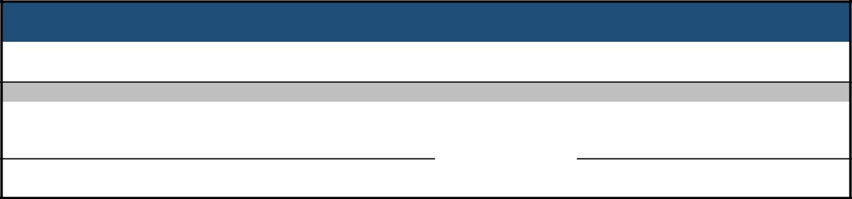
Section 3: Attestation of PQI Project Completion

Diplomate attestation of project completion within the last three calendar years.

Diplomate Attestation of Completion

I, the above-named diplomate in Section 1, has actively participated in and completed the project as specified in Section 2.

Diplomate Signature Date

