RESTROOM CLEANING CHECKLIST

Date:
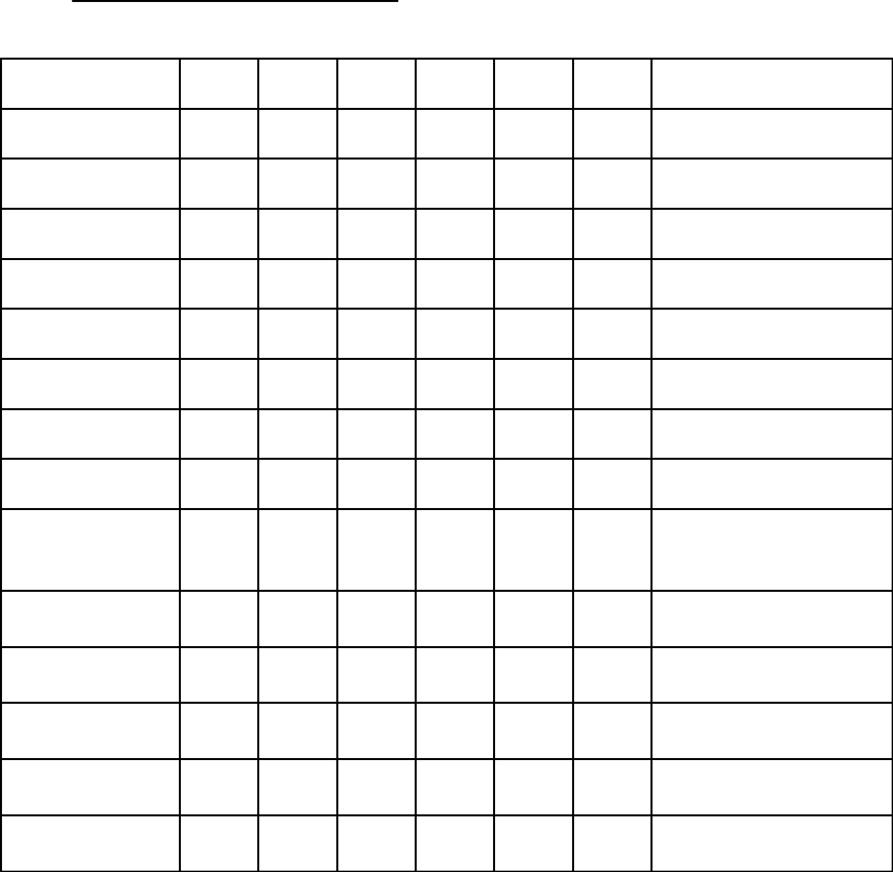

8 AM 10 AM 12 PM 2 PM 4 PM 6 PM Cleaned By

Stock Supplies:

Toilet Paper

Paper Towels

Hand Soap

Air Freshener

Seat Covers

Urinal Cakes

Empty Trash

Clean Sinks,

Countertops and

Fixtures

Polish Soap

Dispensers

Clean Partitions

and Walls

Wipe and Polish

Grab Bars

Sweep and Mop

Floor

Clean Toilets and

Urinals

Comments:

