Daily Restroom Cleaning Checklist

Building: |  |  |  |  |  |  |  | Supervisor:
Room: |  |  |  |  |  |  |  | Week:
Tasks |  |  | Mon |  | Tues |  | Weds |  |  | Thurs |  |  |  | Fri |  |  | Sat |  |  | Sun
 |  | Staff | Time | Staff | Time | Staff |  | Time | Staff |  | Time |  |  | Staff | Time | Staff |  | Time | Staff |  |  | Time
 |  | Initials |  | Initials |  | Initials |  |  | Initials |  |  |  |  | Initials |  | Initials |  |  | Initials
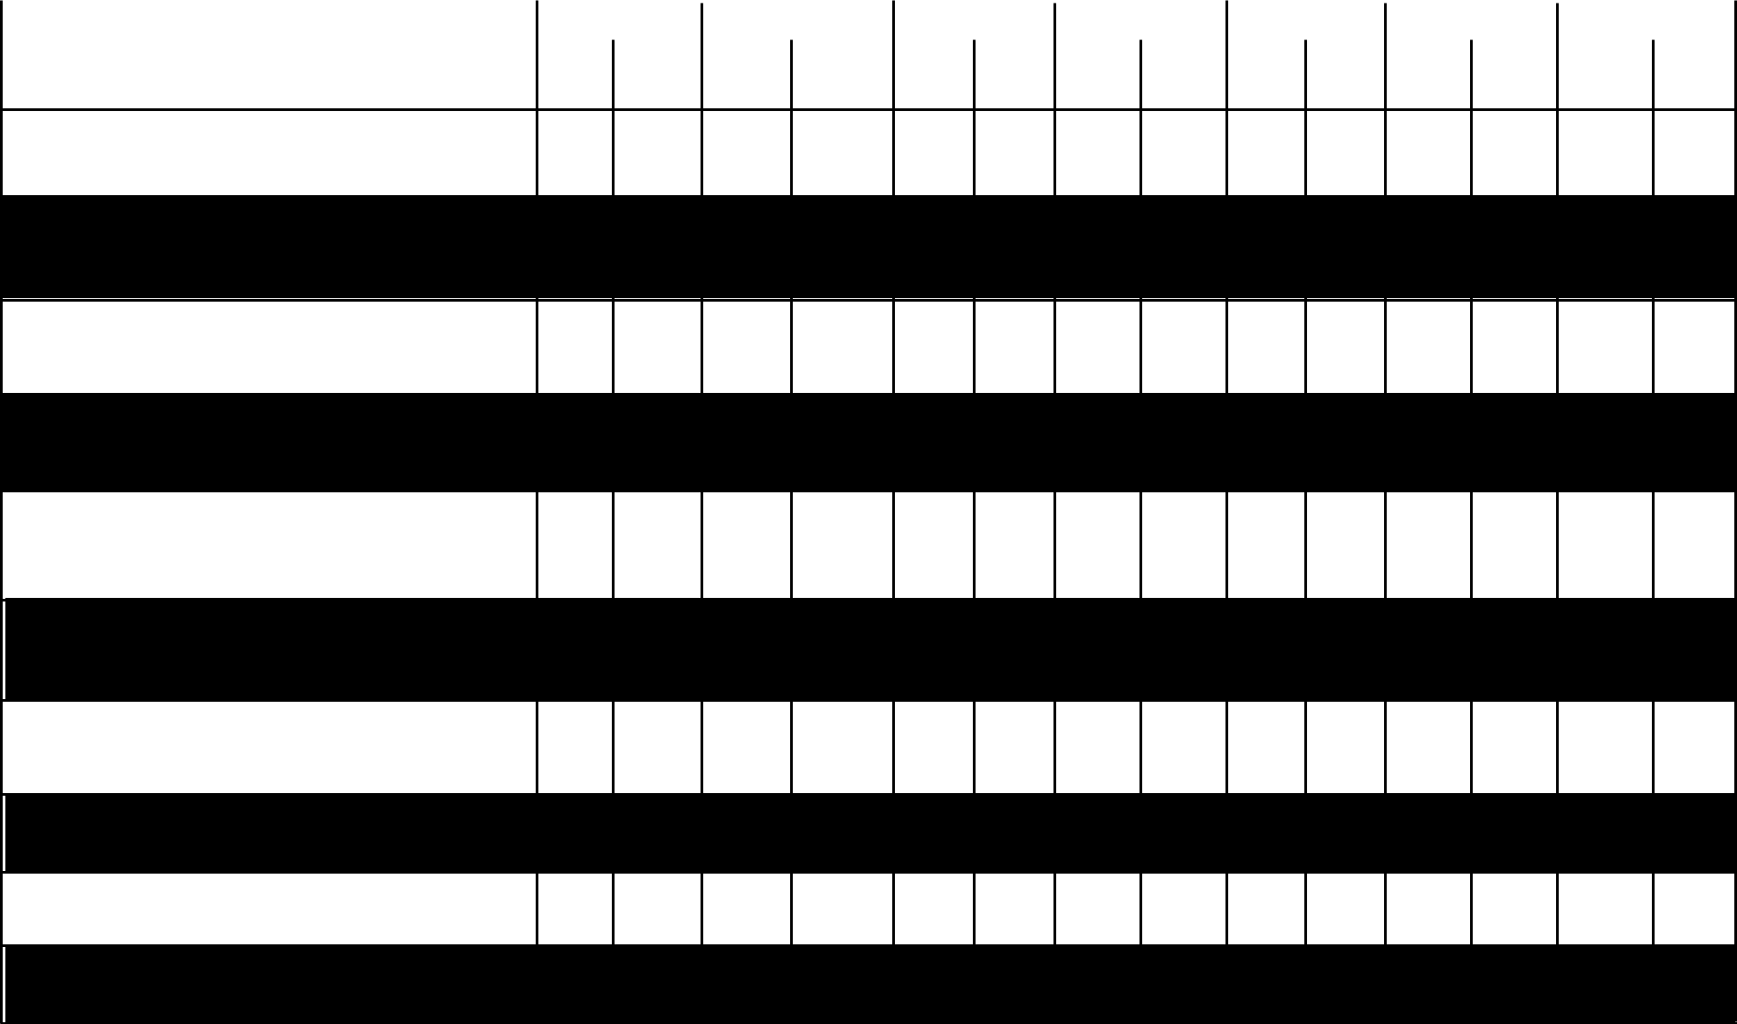

- Apply disinfectant inside toilets and to all touchpoint surfaces

- Check/fill towels/ soap/ air care/ seat covers/ toilet paper

- Pick up all trash/sweep floor/empty trash

- Clean countertops/ sinks/ dispensers

- Clean inside toilets and urinals Wipe outside toilets and urinals

      - Spot clean walls

  - Clean all bright work and mirrors

      - Clean the floor

    - Treat any restroom odors

      - Inspect all areas

