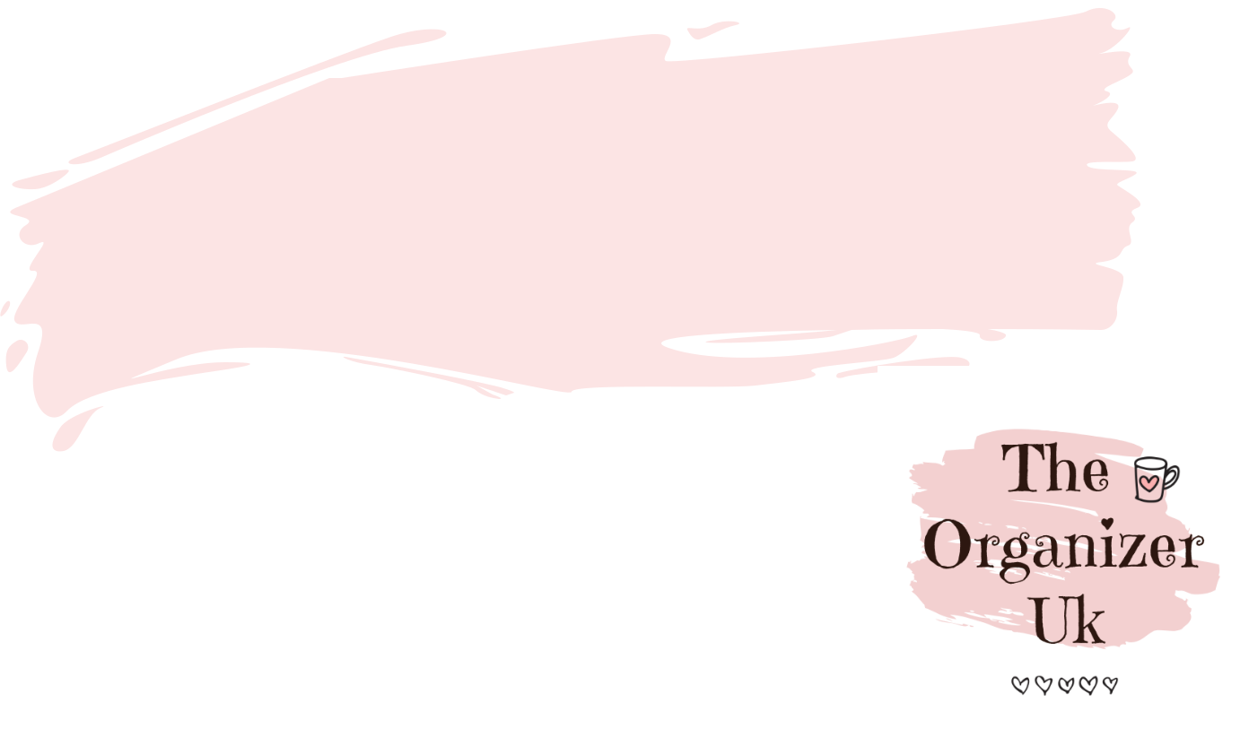
Bathroom cleaning checklist

Vacuum

Clean mirrors

Clean shower and bath
Change towels and bath mat

Empty bin

Clean windows and sills
Clean toilet

Clean sink

Mop floor


Extra job

Empty hair from the shower drain

