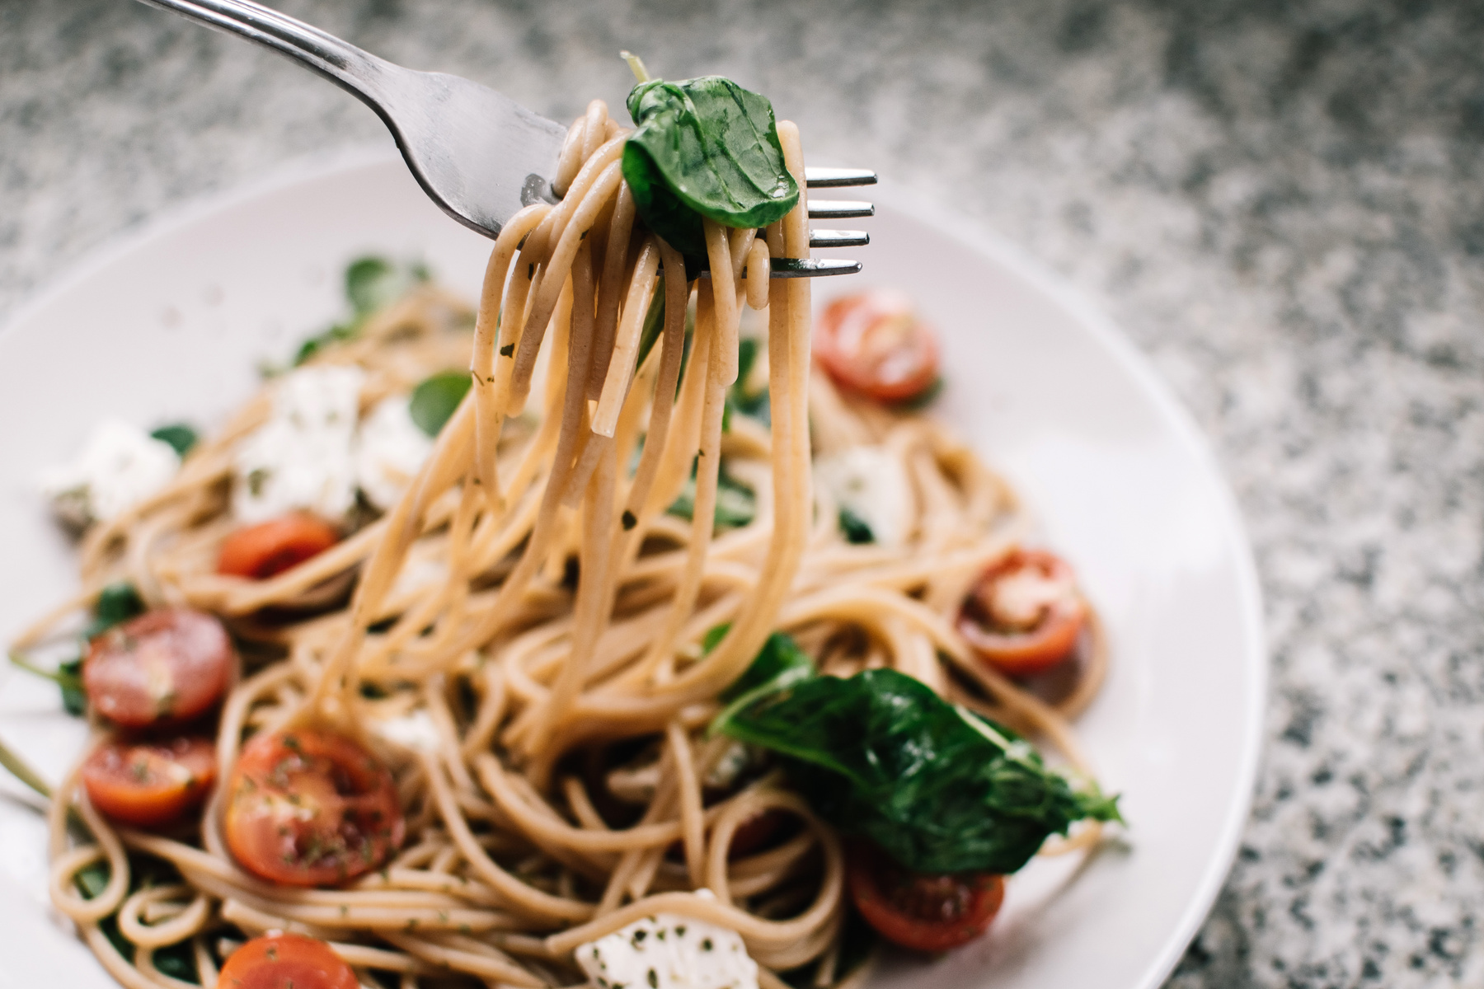

Tomato Basil Pastas

Ingredients

200 grams spaghetti

2 tablespoons olive oil

2 cloves garlic, minced

1 can diced tomatoes

1/2 teaspoon salt

1/2 teaspoon pepper

1/2 cup fresh basil leaves, chopped

1/2 cup grated Parmesan cheese

Directions

* Cook spaghetti according to package instructions. Drain, reserving 1 cup of the pasta water.
* In a skillet, heat olive oil. Sauté garlic until fragrant, then add tomatoes, salt, and pepper. Cook until sauce thickens.
* Add the cooked spaghetti to the skillet, tossing to combine, and adding reserved pasta water if needed.
* Off the heat, garnish with basil and Parmesan. Serve immediately.

Add a pinch of red pepper flakes for a kick.

You can substitute spaghetti with any pasta of your choice.

**Tips:**

*SERVINGS: 2*

*PREPPING TIME: 15 MIN*

*COOKING TIME: 30 MIN*