**INGREDIENTS:**



**TIME TO PREPARE:**

**DIFFICULTY:**

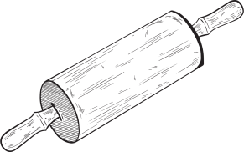

**NAME OF DISH:**

**INSTRUCTIONS:**

**NOTES:**

**Recipe book**