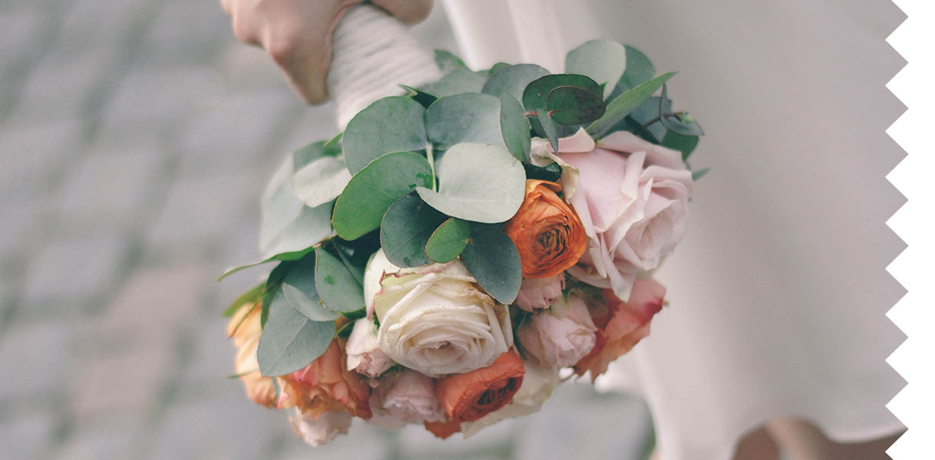

Date Here

The Bride

FREE SEATING

**ADMIT ONE**

**Directed by abc**

**SUNDANCE PRODUCTION PRESENTS**

Movie Name

Ticket no. 0124356