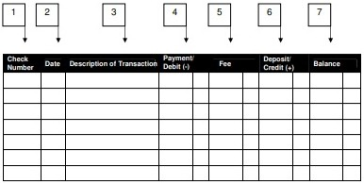

CHECKBOOK REGISTER TEMPLATE