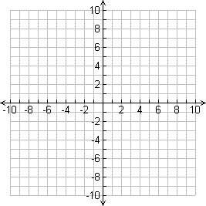 

**GRAPH PAPER FORMATS IDEAS**

