# Graph Paper Design

|  |  |  |  |  |  |
| --- | --- | --- | --- | --- | --- |
|  |  |  |  |  |  |
|  |  |  |  |  |  |
|  |  |  |  |  |  |
|  |  |  |  |  |  |
|  |  |  |  |  |  |
|  |  |  |  |  |  |
|  |  |  |  |  |  |
|  |  |  |  |  |  |

# Two-Centimeter Graph Paper

|  |  |  |  |  |  |  |  |
| --- | --- | --- | --- | --- | --- | --- | --- |
|  |  |  |  |  |  |  |  |
|  |  |  |  |  |  |  |  |
|  |  |  |  |  |  |  |  |
|  |  |  |  |  |  |  |  |
|  |  |  |  |  |  |  |  |
|  |  |  |  |  |  |  |  |
|  |  |  |  |  |  |  |  |
|  |  |  |  |  |  |  |  |
|  |  |  |  |  |  |  |  |
|  |  |  |  |  |  |  |  |
|  |  |  |  |  |  |  |  |
|  |  |  |  |  |  |  |  |

# TANGRAM PAPER

**Handprint Graph Paper**

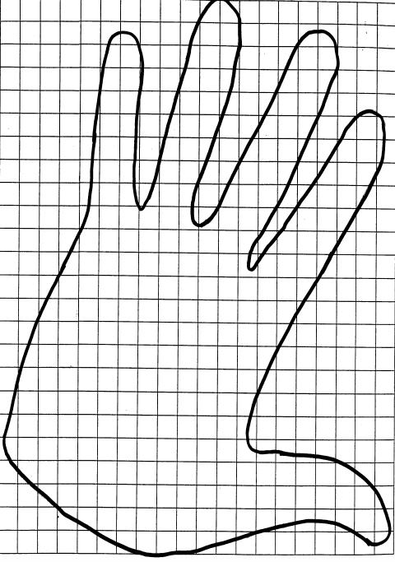

## EQUILATERAL TRIANGLE GRID

|  |  |  |  |  |  |  |
| --- | --- | --- | --- | --- | --- | --- |
|  |  |  |  |  |  |  |
|  |  |  |  |  |  |  |
|  |  |  |  |  |  |  |
|  |  |  |  |  |  |  |
|  |  |  |  |  |  |  |
|  |  |  |  |  |  |  |
|  |  |  |  |  |  |  |
|  |  |  |  |  |  |  |
|  |  |  |  |  |  |  |
|  |  |  |  |  |  |  |

#### S Q U A R E

**G R I D**

## WHICH HOLDS THE MOST?

**Tall Prism**

**Short Prism**



**Tall Cylinder**



**Short Cylinder**

Using four sheets of paper, all the same size,make these four containers. As a group, estimate which has the largest capacity (volume).

We think the has the largest capacity because:

Design an experiment to compare the capacity of each container. Explain your group’s experiment. Describe your procedure and defend your conclusion.

Classroom Strategies Blackline Master 57

II - 9

**BLOCK BOY**

#### 2.25 ft.



**1.5 ft.**

**1.5 ft.**

**12.5 in.**

**1.5 ft.**

**.25 ft.**

**2 in.**

**2 ft.**

**2 ft.**

**4.5 in.**

**20.5 in.**

**1 yd.**

**3.75 ft.**

**2.75 ft.**

**1 in.**

**.5 ft.**

**5 in.**

**5 in.**

58 Classroom Strategies Blackline Master

II - 10

**BLOCK GIRL**

#### 45 cm



**45 cm**

#### 30 cm

**45 cm**

#### 1.1 m

**130 cm**

**90 cm**

**.85 m**

#### 4 cm

**4 cm**

#### 30 cm

**3 cm**

#### 3 cm

**1.4 m 1.6 m**

#### 210 cm

**60 cm**

#### cm

1. **cm**

#### .5 cm

Classroom Strategies Blackline Master 59

II - 11

**HEXAGONAL GRID**

60 Classroom Strategies Blackline Master

II - 12

**Name Date / /**

**Secret Code Grid**

**10 L 9**

**8 Q**

**7 U**

**6**

**5 H**

**4**

**3**

**2 B**

**1 P**

**0**

**T X**

**I F**

**R M**

**E**

**W G**

**A K**

**O Y**

**N V S**

**C**

**D J**

**Z**

**0 1 2 3 4 5 6 7 8 9 10**

What is the code for your friends name? Try writing a secret message for a friend.

Classroom Strategies Blackline Master 61

III - 1

**Name Date / /**

**Half-Inch Graph Paper**

|  |  |  |  |  |  |  |  |  |  |  |  |
| --- | --- | --- | --- | --- | --- | --- | --- | --- | --- | --- | --- |
|  |  |  |  |  |  |  |  |  |  |  |  |
|  |  |  |  |  |  |  |  |  |  |  |  |
|  |  |  |  |  |  |  |  |  |  |  |  |
|  |  |  |  |  |  |  |  |  |  |  |  |
|  |  |  |  |  |  |  |  |  |  |  |  |
|  |  |  |  |  |  |  |  |  |  |  |  |
|  |  |  |  |  |  |  |  |  |  |  |  |
|  |  |  |  |  |  |  |  |  |  |  |  |
|  |  |  |  |  |  |  |  |  |  |  |  |
|  |  |  |  |  |  |  |  |  |  |  |  |
|  |  |  |  |  |  |  |  |  |  |  |  |
|  |  |  |  |  |  |  |  |  |  |  |  |
|  |  |  |  |  |  |  |  |  |  |  |  |
|  |  |  |  |  |  |  |  |  |  |  |  |
|  |  |  |  |  |  |  |  |  |  |  |  |
|  |  |  |  |  |  |  |  |  |  |  |  |

62 Classroom Strategies Blackline Master

III - 2

# One-Centimeter Graph Paper

|  |  |  |  |  |  |  |  |  |  |  |  |  |  |  |  |  |
| --- | --- | --- | --- | --- | --- | --- | --- | --- | --- | --- | --- | --- | --- | --- | --- | --- |
|  |  |  |  |  |  |  |  |  |  |  |  |  |  |  |  |  |
|  |  |  |  |  |  |  |  |  |  |  |  |  |  |  |  |  |
|  |  |  |  |  |  |  |  |  |  |  |  |  |  |  |  |  |
|  |  |  |  |  |  |  |  |  |  |  |  |  |  |  |  |  |
|  |  |  |  |  |  |  |  |  |  |  |  |  |  |  |  |  |
|  |  |  |  |  |  |  |  |  |  |  |  |  |  |  |  |  |
|  |  |  |  |  |  |  |  |  |  |  |  |  |  |  |  |  |
|  |  |  |  |  |  |  |  |  |  |  |  |  |  |  |  |  |
|  |  |  |  |  |  |  |  |  |  |  |  |  |  |  |  |  |
|  |  |  |  |  |  |  |  |  |  |  |  |  |  |  |  |  |
|  |  |  |  |  |  |  |  |  |  |  |  |  |  |  |  |  |
|  |  |  |  |  |  |  |  |  |  |  |  |  |  |  |  |  |
|  |  |  |  |  |  |  |  |  |  |  |  |  |  |  |  |  |
|  |  |  |  |  |  |  |  |  |  |  |  |  |  |  |  |  |
|  |  |  |  |  |  |  |  |  |  |  |  |  |  |  |  |  |
|  |  |  |  |  |  |  |  |  |  |  |  |  |  |  |  |  |
|  |  |  |  |  |  |  |  |  |  |  |  |  |  |  |  |  |
|  |  |  |  |  |  |  |  |  |  |  |  |  |  |  |  |  |
|  |  |  |  |  |  |  |  |  |  |  |  |  |  |  |  |  |
|  |  |  |  |  |  |  |  |  |  |  |  |  |  |  |  |  |
|  |  |  |  |  |  |  |  |  |  |  |  |  |  |  |  |  |
|  |  |  |  |  |  |  |  |  |  |  |  |  |  |  |  |  |
|  |  |  |  |  |  |  |  |  |  |  |  |  |  |  |  |  |
|  |  |  |  |  |  |  |  |  |  |  |  |  |  |  |  |  |

Classroom Strategies Blackline Master 63

III - 3

## Name Date / /

•

•

•

•

•

•

•

•

•

•

•

•

•

•

•

•

•

•

•

•

•

•

•

•

•

•

•

•

•

•

•

•

•

•

•

•

•

•

•

•

•

•

•

•

•

•

•

•

•

•

**1.**

**2.**

**3.**

**4.**

**5.**

**6.**

•

•

•

•

•

•

•

•

•

•

•

•

•

•

•

•

•

•

•

•

•

•

•

•

•

•

•

•

•

•

•

•

•

•

•

•

•

•

•

•

•

•

•

•

•

•

•

•

•

•

•

•

•

•

•

•

•

•

•

•

•

•

•

•

•

•

•

•

•

•

•

•

•

•

•

•

•

•

•

•

•

•

•

•

•

•

•

•

•

•

•

•

•

•

•

•

•

•

•

•

III - 5

**Name Date / /**

Classroom Strategies Blackline Master

65

Using Coordinates

1. Connect these points in order. What picture do you see?

(6,7) (17 1/2, 7) (18, 6) (18 1/2, 4) (16 1/2, 2) (15, 2) (14, 1) (12 1/2, 0) (8, 2 1/2) (8, 3) (5, 3 1/2) (4,3) (0, 3)

(0, 3 1/2) (5 1/2, 6) (6, 7)

**16**

**15**

**14**

**13**

**12**

**11**

**10**

**9**

**8**

**7**

**6**

**5**

**4**

**3**

**2**

**1**

**0 1 2 3 4 5 6 7 8 9 10 11 12 13 14 15 16 17 18 19 20 21 22 23 24 25 26 27**

1. Use your own graph paper to see what happens when you multiply each number in the pairs above by 2.
2. What happens when only the first numbers of the ordered pairs are multiplied by 2?
3. What happens when you double the second numbers of the ordered pairs?

***Direction for Making Burrito Books***

***Cut***



### Fold paper in half. Cut on the fold. Fold each half again (short side together).



***Cut***

Take one piece and cut on fold 1/3 down from the top and 1/3 up from the bottom leaving the center 1/3 uncut.



***Slit***

### Take the other piece of paper and slit the center 1/3 on the fold.

Roll the first piece of paper so it fits through the slit and... whoop! There it is!

66 Classroom Strategies Blackline Master

III - 6

**Tessellation Originals**

You can create note paper, postcards, wrapping paper, and pictures for many purposes with original tessellations. Here are the basic steps you need to follow. Experiment with squares, rectangles, triangles, and other shapes which will tessellate. Why are equilateral triangles easier than scalene triangles?

#### step 1

**step 2**

#### step 3 step 4 step 5

Step 1. Start with a shape which will tessellate, for example a square. (A shape will tessellate if the sum of the angles is a multiple of 180).

Step 2. Draw a simple squiggly line from corner to corner along one side Cut out the shape.

Step 3. Slide (translate) the shape to the opposite side and tape into place. Be very careful to attach the corners. Trim off excess tape.

Step 4. Repeat the process using the remaining two sides.

Step 5. Place this new shape on the notepaper, postcard, wrapping paper, etc. and trace around it. Slide the shape to a new positio fitting into the outline of the first tracing. Trace around the shape over and over until the paper is covered (tiled).

n,

Step 6. Look at the tiling-turn (rotate it, squint at it - what could it be? Step 7. Add in the features and details.

Step 8. Add color to your design and sign!

#### Step 6

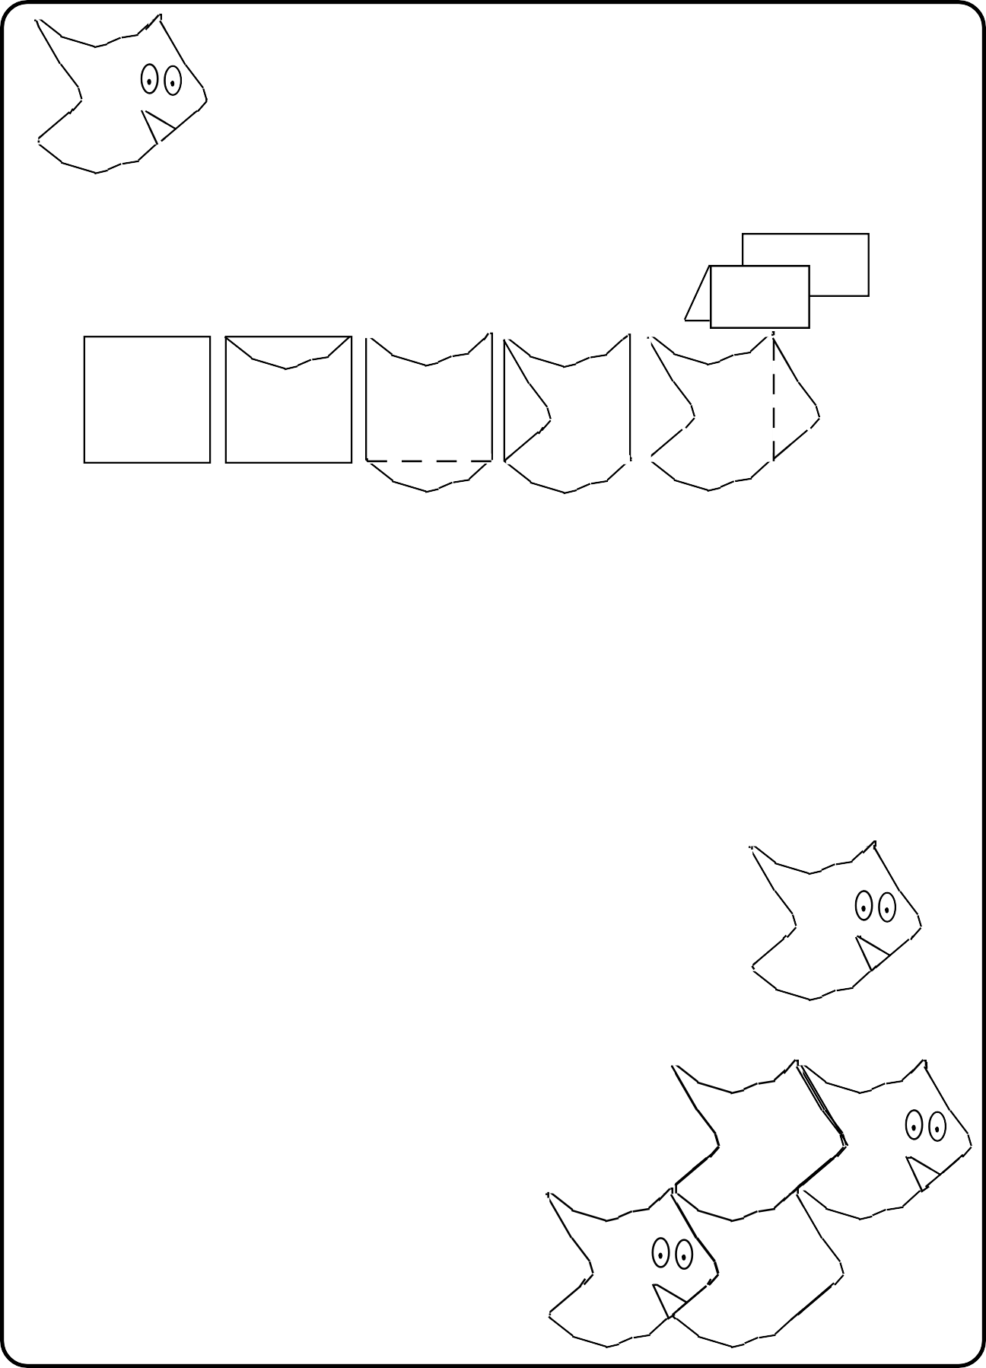

**Step 7**

Debugging: If your shape does not fit together like pieces of a jigsaw puzzle... check to make sure that pieces were not flipped while being translated to opposite sides.

he

t

Classroom Strategies Blackline Master 67

III - 7

**A Problem Solving Guide**

1. **Read the problem twice.**
2. **Draw a picture.**
3. **Decide what the problem is asking.**
4. **Write a number sentence.**
5. **Does the picture match the number sentence?**
6. **Solve the problem.**
7. **Does the answer make sense?**
8. **Read the problem one more time.**

**A Problem Solving Guide**

1. **Read the problem twice.**
2. **Draw a picture.**
3. **Decide what the problem is asking.**
4. **Write a number sentence.**
5. **Does the picture match the number sentence?**
6. **Solve the problem.**
7. **Does the answer make sense?**
8. **Read the problem one more time.**

68 Classroom Strategies Blackline Master

III - 8

**STUDENT CENSUS**

## Name First Middle Last

**Date of Birth Age month day year**

## What country were you born in ?

**Address**

## Street

**City State Zip Code**

## Telephone Number

**Number of people who live at this address**

## Number of brothers Number of sisters

**Hair color Eye color**

## Check one:

**right-handed**

## left-handed

**Circle the grades attended at this school K 1 2 3**

## How do you usually come to school? (Check one)

**car**

**bus**

## walk

**bicycle**

## other

**Circle your favorite subject. reading math science social studies What is your favorite activity? (Check one)**

## playing

**watching TV**

## reading

**other**

Classroom Strategies Blackline Master 69

IV - 1

## Name Date

70 Classroom Strategies Blackline Master

IV - 2

## Name Date

Classroom Strategies Blackline Master 71

IV - 3

## Name Date

72 Classroom Strategies Blackline Master

IV - 4

## Name Date

Classroom Strategies Blackline Master 73

IV - 5

## Name Date

**Graph Paper Template**

## Name Date

Classroom Strategies Blackline Master 75

IV - 7

76 Classroom Strategies Blackline Master

IV - 8

Classroom Strategies Blackline Master 77

IV - 9

**A**

**B**

**C**

**D**

**E**

**F**

78 Classroom Strategies Blackline Master

IV - 10

**Tricky Three**

subtract

3

add

2

add

3

subtract

1

add

0

subtract

2

add

1

add

3



|  |  |  |  |  |  |  |  |  |  |  |
| --- | --- | --- | --- | --- | --- | --- | --- | --- | --- | --- |
| player # 1 |  |  |  |  |  |  |  |  |  |  |
| player # 2 |  |  |  |  |  |  |  |  |  |  |

|  |  |  |  |  |  |  |  |  |  |  |
| --- | --- | --- | --- | --- | --- | --- | --- | --- | --- | --- |
| player # 1 |  |  |  |  |  |  |  |  |  |  |
| player # 2 |  |  |  |  |  |  |  |  |  |  |

|  |  |  |  |  |  |  |  |  |  |  |
| --- | --- | --- | --- | --- | --- | --- | --- | --- | --- | --- |
| player # 1 |  |  |  |  |  |  |  |  |  |  |
| player # 2 |  |  |  |  |  |  |  |  |  |  |

Classroom Strategies Blackline Master 79

IV - 11

### Name Date / /

**ONE HUNDRED GRID**

|  |  |  |  |  |  |  |  |  |  |
| --- | --- | --- | --- | --- | --- | --- | --- | --- | --- |
|  |  |  |  |  |  |  |  |  |  |
|  |  |  |  |  |  |  |  |  |  |
|  |  |  |  |  |  |  |  |  |  |
|  |  |  |  |  |  |  |  |  |  |
|  |  |  |  |  |  |  |  |  |  |
|  |  |  |  |  |  |  |  |  |  |
|  |  |  |  |  |  |  |  |  |  |
|  |  |  |  |  |  |  |  |  |  |
|  |  |  |  |  |  |  |  |  |  |
|  |  |  |  |  |  |  |  |  |  |

80 Classroom Strategies Blackline Master

V - 1

V - 2

Name

Date

/

/

Classroom Strategies Blackline Master

81

|  |  |  |  |  |  |  |  |  |  |
| --- | --- | --- | --- | --- | --- | --- | --- | --- | --- |
| **1** | **2** | **3** | **4** | **5** | **6** | **7** | **8** | **9** | **10** |
| **11** | **12** | **13** | **14** | **15** | **16** | **17** | **18** | **19** | **20** |
| **21** | **22** | **23** | **24** | **25** | **26** | **27** | **28** | **29** | **30** |
| **31** | **32** | **33** | **34** | **35** | **36** | **37** | **38** | **39** | **40** |
| **41** | **42** | **43** | **44** | **45** | **46** | **47** | **48** | **49** | **50** |
| **51** | **52** | **53** | **54** | **55** | **56** | **57** | **58** | **59** | **60** |
| **61** | **62** | **63** | **64** | **65** | **66** | **67** | **68** | **69** | **70** |
| **71** | **72** | **73** | **74** | **75** | **76** | **77** | **78** | **79** | **80** |
| **81** | **82** | **83** | **84** | **85** | **86** | **87** | **88** | **89** | **90** |
| **91** | **92** | **93** | **94** | **95** | **96** | **97** | **98** | **99** | **100** |

Name

**Bowl ‘em Over!**

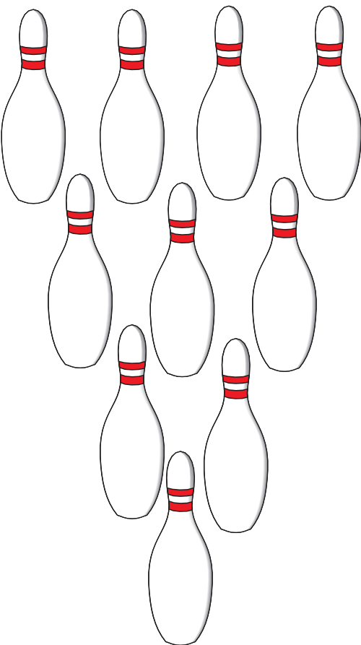

**7**

**8**

**9**

**10**

**4**

**5**

**6**

**2**

**3**

**1**

Date / /

**My Score:**

**Round 1 Round 2 Round 3 Round 4 Round 5 TOTAL**

|  |  |  |  |  |  |
| --- | --- | --- | --- | --- | --- |
|  |  |  |  |  |  |
|  |  |  |  |  |  |
|  |  |  |  |  |  |
|  |  |  |  |  |  |
|  |  |  |  |  |  |

82 Classroom Strategies Blackline Master

V - 3

### Name Date / /

Classroom Strategies Blackline Master 83

V - 4

### Name Date / /

84 Classroom Strategies Blackline Master

V - 5

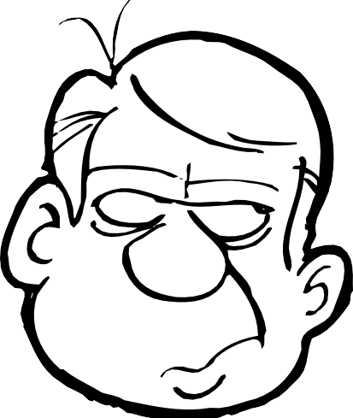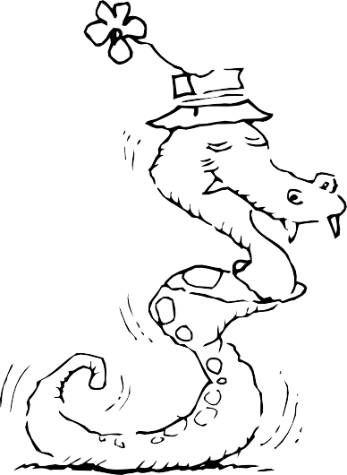

Classroom Strategies Blackline Master 85

V - 6

Name Date / /

## Figure #1 Figure #2 Figure #3

### How many rhombuses did you need to build each figure? Complete the chart.

|  |  |
| --- | --- |
| **Figure Number** | **Number of Rhombuses** |
| 1 |  |
| 2 |  |
| 3 |  |
| 4 |  |
| 5 |  |

1. How many rhombuses would you need to make each figure?

### a. Figure 8 b. Figure 10

c. Figure 20 d. Figure 100

### Write a sentence to describe the pattern between the figure number and the number of rhombuses.

1. If a figure uses 36 rhombuses, what is its figure number?

86 Classroom Strategies Blackline Master

V - 7