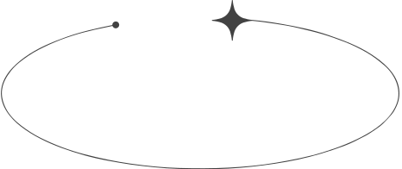

LASH

PRICE LIST

Eyelash Extensions

$0

$0

$0

$0

$0

$0

$0

Lash Lift

Master Stylist Upgrades

Lash Upgrades

Eyebrow Shaping etc.

Full Set Upgrade

Brow Lamination

